Estimate Security Copilot Agentic Defense

Estimate Security Copilot Agentic Defense 1
1. Project Perception Overview 1
1.1 Agent Roles and Hand-offs 1
1.2 Platform Components and Governance 1
2. Cost: How the Estimate Is Built 2
2.1 Pricing model 2
2.2 Estimation method 2
Agent inventory and SCU basis 3
2.3 Costs not covered by the E5 inclusion 3
2.4 Project Perception Cost Considerations 3
3. Variables Affecting Cost 6
3.1 Deductions: E5 SCU inclusion and discounts 6
3.2 Growth: number of incidents and agent activity 6
3.3 Control: scaling agents on and off 6

1. Project Perception Overview
Project Perception is Microsoft's agentic security system, currently in preview. It coordinates three classes of specialized agents (red, blue and green) across the attack lifecycle. It complements Security Copilot: Security Copilot is the generative AI interface that assists analysts, while Project Perception is the agentic system that performs investigation and remediation work autonomously within defined guardrails. At launch it operates inside Microsoft Defender, and Microsoft states it will extend across the wider security portfolio.

1.1 Agent Roles and Hand-offs
- Red agents emulate attacker behavior to expose vulnerabilities and control gaps.
- Blue agents detect, investigate and respond to threats. Threat hunting and detection agents are already delivered; the extension is incident-driven investigation at full volume.
- Green agents remediate and harden the environment. Remediation agents are already delivered; the extension is automated remediation with approval gates.
Findings pass between classes through shared intelligence and orchestrated workflows, so a red-agent finding becomes a blue-agent investigation and a green-agent fix without a manual hand-off at each step.

1.2 Platform Components and Governance
The system comprises six building blocks: the red, blue and green agents; purpose-built cyber models (including MAI-Cyber-1-Flash); organizational context (past incidents, policy decisions, identity relationships); signals and sensors across endpoints, identities, clouds and apps; actuators that convert a decision into an action rather than a recommendation; and an orchestration harness that controls and tests agent behavior.
Governance is designed around human control. Defenders set objectives and guardrails, every high-impact action requires human sign-off, and each decision is scoped, traceable and repayable. Pricing is consumption-based, with agents metered at different rates according to task intensity. Figure 1 shows the hand-off model.
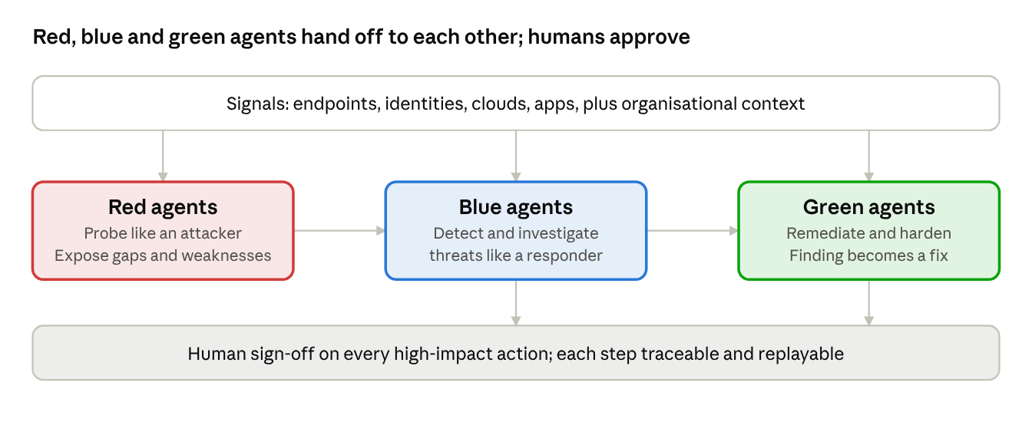
Project Perception agent loop · 3 agents, 1 approval gate
Signals feed all three agents; blue and green actions pass through human approval before they take effect.
Figure 1. Agent hand-off model. Source: Microsoft Security, Project Perception product page.

2. Cost: How the Estimate Is Built

2.1 Pricing model
Cost is driven by SCU consumption rather than user count. Tesco holds Microsoft 365 E5 licenses and therefore falls under the inclusion model: a monthly SCU pool is covered by the license, and only demand above that pool is incremental.
- Standalone model (no E5): provisioned SCUs are billed hourly at $4 per SCU whether used or not, with a minimum of 1 SCU. Overage is billed only when used, at $6 per SCU.
- E5/E7 inclusion model (applies here): a monthly SCU pool is included at no extra cost, only actual consumption is deducted, and there is no hourly provisioning. Beyond the pool, $6 per SCU pay-as-you-go applies.

2.2 Estimation method
- Define the agent inventory: incident triage and summarization, phishing triage, knowledge-base (KB) grounded agent, and custom agents built with Agent Builder.
- Establish volumes per agent: incidents per month, user-reported phishing per month, and scheduled runs per day or week, from the last 3 to 6 months of operational data.
- Determine SCUs per run using the Microsoft SCU Calculator. Microsoft's reference points: incident summarization about 0.5 SCU, and prompt execution about 3 SCU.
- Calculate monthly consumption as runs multiplied by SCUs per run, summed across agents.
- Apply the E5 inclusion and price any remainder at $6 per SCU.
- Add costs outside the SCU pool and the Project Perception line, then multiply by 12 for the annual figure.
Monthly overage cost = max(0, SCUs consumed - SCUs included) × $6
SCUs consumed = Σ (runs per month × SCUs per run), across all agents

Agent inventory and SCU basis
- Incident summarization and triage: triggered per incident; volume driver is incidents per month; 0.5 SCU per run (Microsoft reference, to be validated in the calculator).
- Phishing triage: triggered per user-reported email; volume driver is reports per month; SCUs per run [TBC].
- KB-grounded agent: triggered per analyst query; volume driver is queries per month; SCUs per run [TBC].
- Custom agents (Agent Builder): scheduled or on demand; volume driver runs per month; SCUs per run [TBC].

2.3 Costs not covered by the E5 inclusion
Microsoft states the following require separate payment and must be budgeted outside the SCU pool:
- Microsoft Sentinel data lake compute and storage
- Non-agentic Data Security Investigations in Microsoft Purview
- Azure Logic Apps charges incurred by Security Copilot workflows
- Partner-built agent licenses sold through Security Store (SCU cost is included for now; this may change)
- Prerequisites for specific agents that sit outside the E5 stack
Project Perception rates are not yet published and must be confirmed with the Microsoft account team as the offering leaves preview.

2.4 Project Perception Cost Considerations
Project Perception is priced on consumption (pay-as-you-go), and Microsoft meters each agent at a different rate depending on the intensity of the task. Per-agent rates have not been published, so the red, blue and green agents cannot yet be costed in the calculator. Whether Project Perception consumption draws on the E5 SCU pool is not confirmed in the material reviewed and must be verified with Microsoft.

The Microsoft SCU calculator sizes capacity from the number of people expected to use Copilot in each product per month. Inputs used: Microsoft Defender 10, Microsoft Purview 5, Microsoft Intune 5, Microsoft Entra 5, and the Security Copilot standalone portal 5. Workflow automation: No. The calculator returns 7 SCUs per hour.
Calculator Inputs:

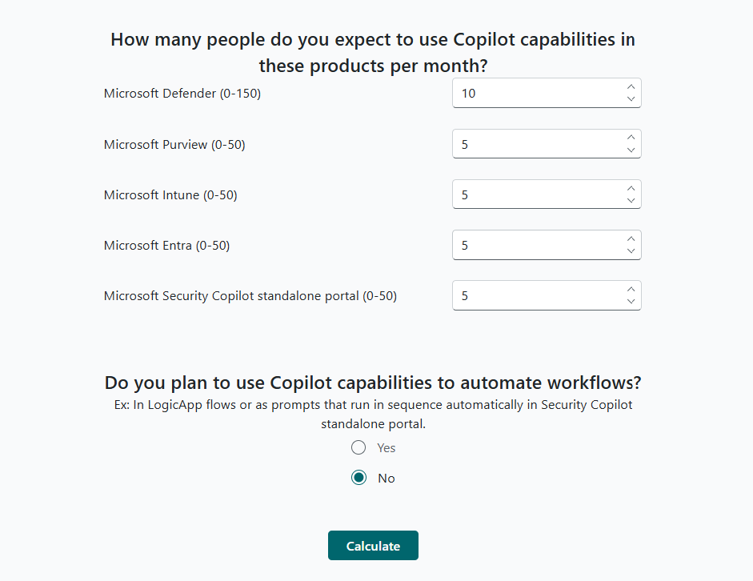

Calculator Result Table:

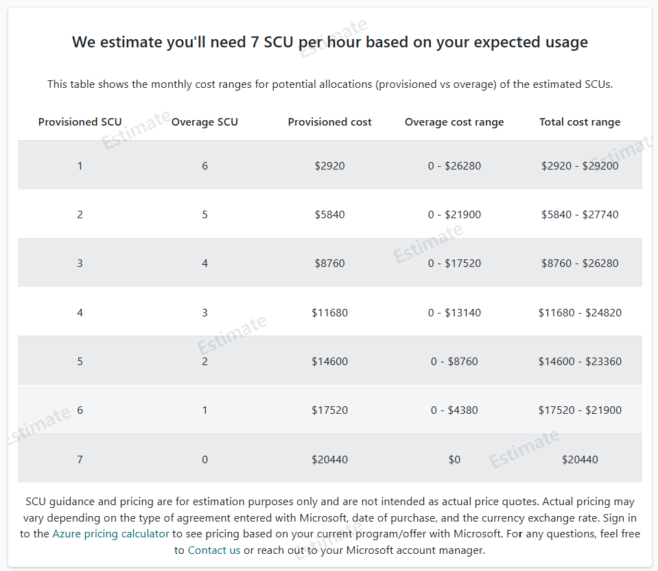
Gross cost on the standalone model, before any E5 inclusion (provisioned rate $2,920 per SCU per month, which is $4 × 730 hours; overage rate $4,380 per SCU per month, which is $6 × 730 hours):
- Fully provisioned (7 SCUs): $20,440 per month, $245,280 per year.
- Fully overage (7 SCUs, ceiling): $30,660 per month, $367,920 per year.
- Mixed: any split between the two falls in the calculator’s range. For example, 1 provisioned plus 6 overage ranges from $2,920 to $29,200 per month.
This figure is a ceiling, not a forecast. The calculator estimates user-driven prompt usage only and does not size agent runs. Microsoft directs agent estimates to the account manager. Section 2.2 covers agent consumption separately.
Effect of the E5 inclusion. 7 SCUs per hour over 730 hours is a ceiling of 5,110 SCUs per month at full utilisation. The included pool is (E5 licences ÷ 1,000) × 400, capped at 10,000 SCUs per month, and only the overage above the pool is charged, at $6 per SCU:
Monthly overage at ceiling = max (0, 5,110 - pool) × $6

- 5,000 E5 licences (pool 2,000): 3,110 SCUs over the pool, $18,660 per month.
- 10,000 E5 licences (pool 4,000): 1,110 SCUs over the pool, $6,660 per month.
- 12,775 or more E5 licences (pool 5,110 or more): the pool covers the full ceiling, $0 incremental.
- Actual licence count [TBC]: substitute the tenant’s E5 total in the formula above.
Sustained consumption at the ceiling is unlikely. Budget between the pool-covered case ($0 incremental) and the ceiling, then replace the range with measured figures from the usage dashboard after the first phase. Because $6 pay-as-you-go overage costs more than $4 provisioned capacity, confirm with Microsoft whether provisioned capacity can be added alongside the E5 pool if sustained demand exceeds it.

3. Variables Affecting Cost

3.1 Deductions: E5 SCU inclusion and discounts
- E5/E7 inclusion: 400 SCUs per month for every 1,000 paid user licenses, up to 10,000 SCUs per month, at no additional cost. The allocation scales down proportionally below 1,000 licenses (400 licenses gives 160 SCUs). It resets monthly and does not roll over.
- Included SCUs formula: (E5 licenses ÷ 1,000) × 400, capped at 10,000. [TBC: license count and result]
- Provisioning: zero-click, with no Azure setup. The tenant receives a Default Security Copilot Capacity that cannot be modified and is not billed hourly. Cost values shown in the UI for this capacity are informational only. Any previously provisioned capacity should be retained.
- Commercial discounts: Microsoft states that actual pricing varies with the type of agreement, date of purchase and currency exchange rate, so any negotiated discount must be confirmed and applied to the billable remainder.
- Partner-built agents: SCU costs are included until further notice, but partner license fees are separate.
Number Of Licenses (E5/E7) | SCU discounted | Cost Discounted
XXXXXX | XXXX | XXXX

3.2 Growth: number of incidents and agent activity
Consumption is driven by volume and task complexity, not by user count. Additional incidents, automated triggers and longer investigations all increase SCU use. Microsoft states that usage above the included pool will be throttled at a future date, with 30 days' advance notice, after which customers may scale at $6 per SCU pay-as-you-go.
Planning guidance: size the budget on the base scenario, hold a contingency equal to the high scenario, and review actual consumption monthly against the pool. Incident volume should be forecast for 12 months, since each additional 1,000 incidents adds about 500 SCUs at 0.5 SCU per incident, or $3,000 per month once the pool is exhausted.

3.3 Control: scaling agents on and off
Agent-level cost control is available, as documented by Microsoft:
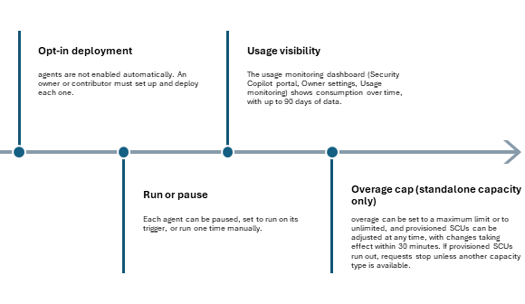

- Opt-in deployment: agents are not enabled automatically. An owner or contributor must set up and deploy each one.
- Run or pause: each agent can be paused, set to run on its trigger, or run one time manually.
- Usage visibility: the usage monitoring dashboard (Security Copilot portal, Owner settings, Usage monitoring) shows consumption over time, with up to 90 days of data.
- Overage cap (standalone capacity only): overage can be set to a maximum limit or to unlimited, and provisioned SCUs can be adjusted at any time, with changes taking effect within 30 minutes. If provisioned SCUs run out, requests stop unless another capacity type is available.
Recommended approach: deploy the highest-value agents first, review the dashboard weekly for the first month, pause low-value agents, and run heavy agents on demand during peak periods.

